# 

# REPAIR

# Repair management

This module was developed for use in a motor garage.

It may of course be adapted to manage other activity as after sales per example.

It has been developed on an XOOPS 2.4 and the tests on a XOOPS 2.5 are conclusive.

The needs was to have a tool for managing repairs in a car garage. Two different areas, mechanical and bodywork, few workers in each sector.

The module allows managing maintenance cars park in the garage, follow interventions underway and completed, edit quotes and invoices.

## Detailed description

1. Admin area
   1. Customers
   2. Vehicles
   3. Suppliers
   4. Categories of spare parts
   5. Spare parts
   6. Package
   7. Brands
   8. Workers
   9. Documentation
   10. Trash
   11. Repair task
   12. Editions
   13. Preferences of the module
2. User area

# Administration

### New GUI Interface look

As explain by Mamba [here](http://xoops.org/modules/newbb/viewtopic.php?topic_id=73531&forum=75) Mage has created a new class for admin and it gives a fresh admin interface, auto compute via the menu.php.

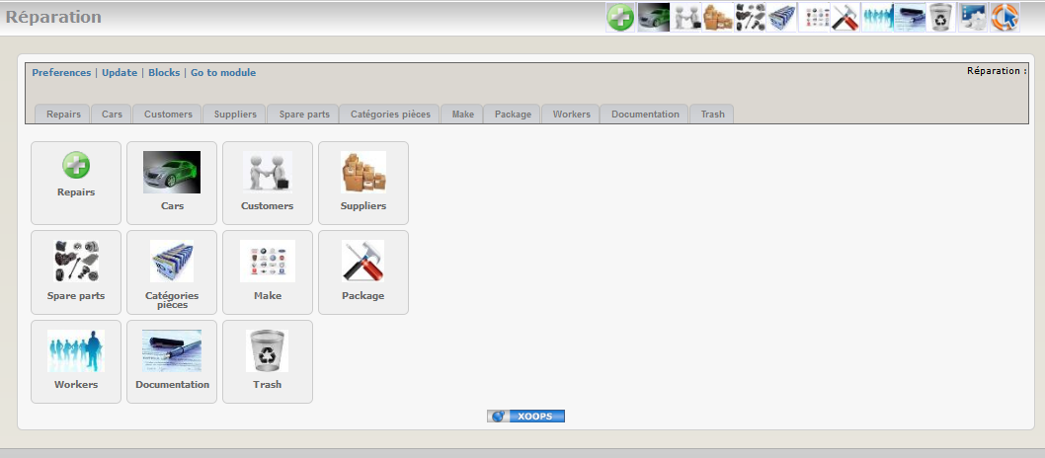

### Customers

You can store all customers information in the database. It’s of course usefull for regular customers.

List of customer records :

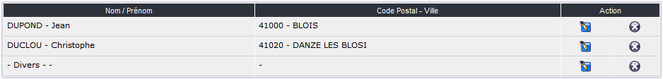

Form for adding a new customer:

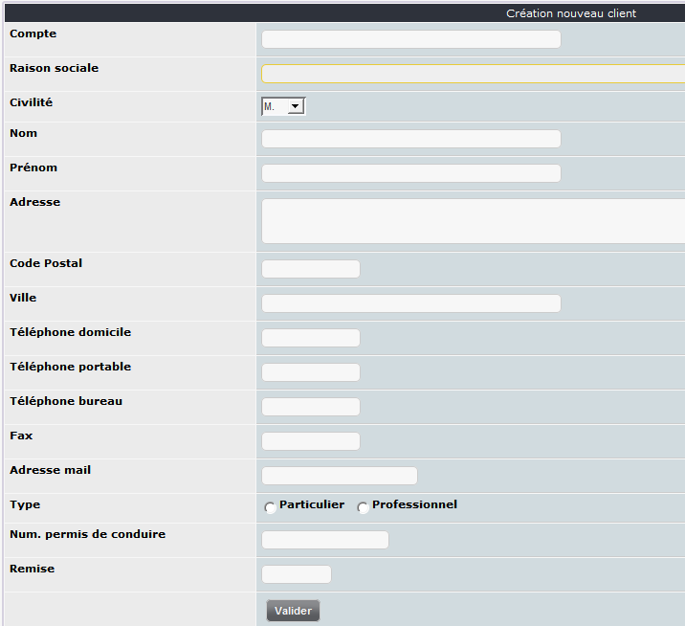

### Véhicles

This tab is dedicated to vehicle maintenance management in the garage.

List of registered vehicles:

Form to add a new vehicle:

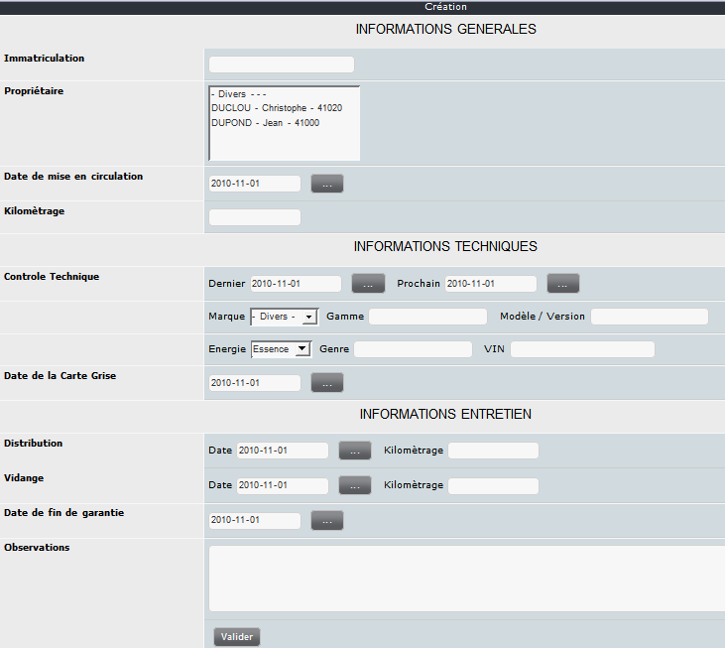

### Suppliers

Registered supplier list:



Form to add a new supplier:

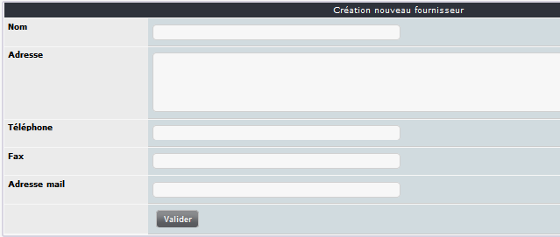

### Spare parts categories

Using categories allow sorting the spare parts.

Categories list:

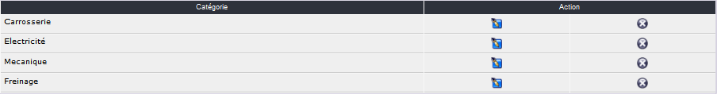

Form to add a new category:

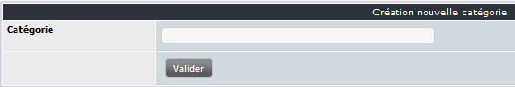

### Spare parts

As it’s possible to have many spare parts in the full list a small tab is available to show / hide the spare parts list.

Spare parts list :



Form to add a new spare part :

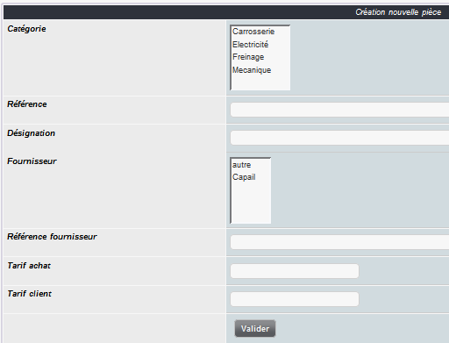

### Package

Package list:



Form to add a new package:

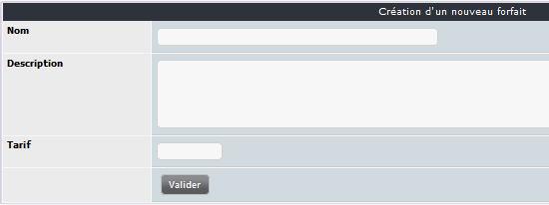

When you have submitted the first form a new one is shown and allow adding spare parts.

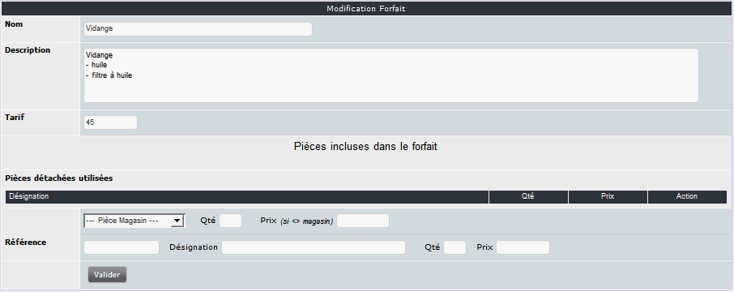

### Brands

Few brands are already included when you install the module. You can of course add other brands.

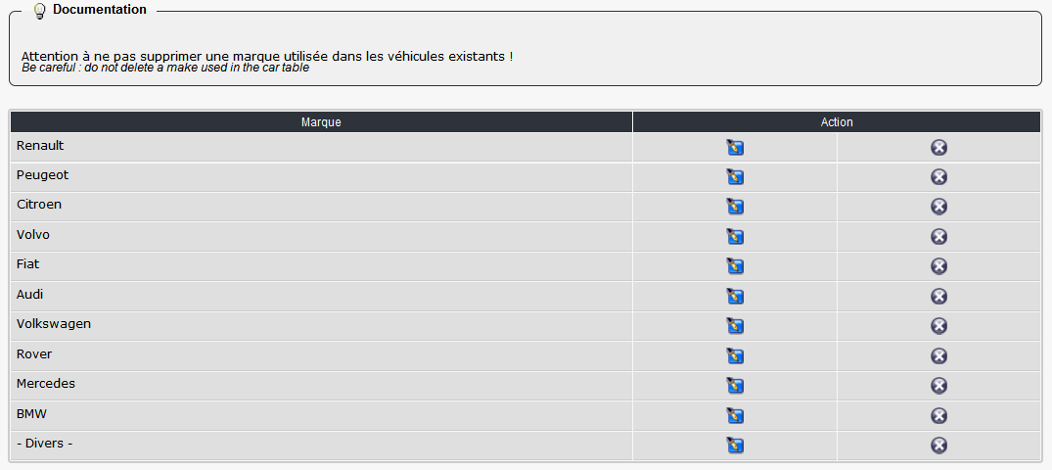

Form to add a new brand:

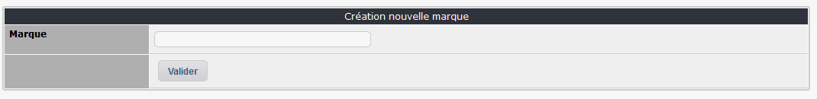

### Workers

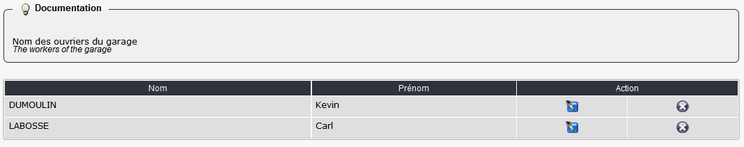

Form to add a new worker:

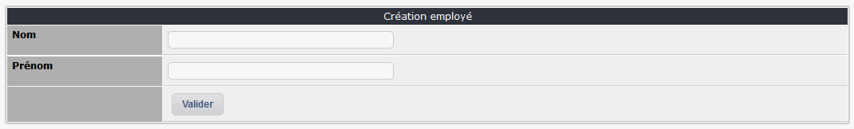

### Documentation

An integrated documentation system is available. It help the administrator of the module by showing specific tips in each admin tabs.

You can of course update these tips by adding your own info. It can be usefull when you use some tabs rarely or if you delegate the admin of the module to a non advanced user.

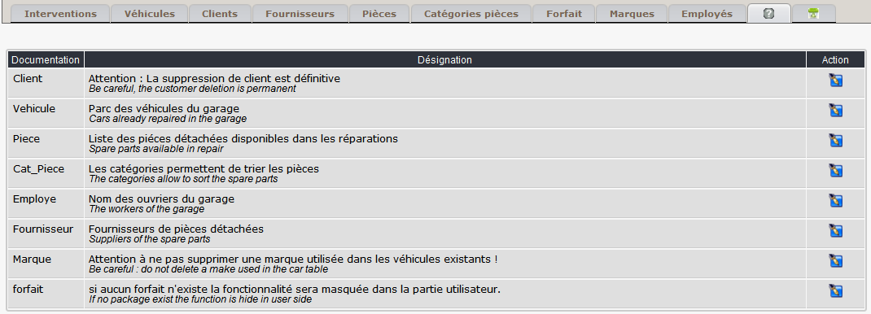

### Trash

A trash system is available to undelete a repair deleted by mistake ;-).

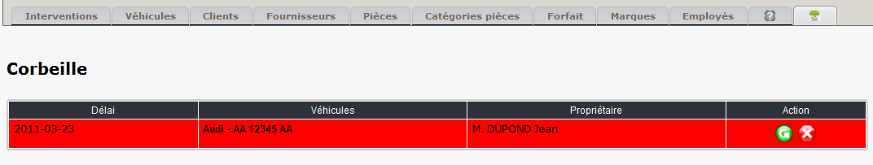

### Repair task

#### Logical process

You can add a new repair task both in admin area and in user side.

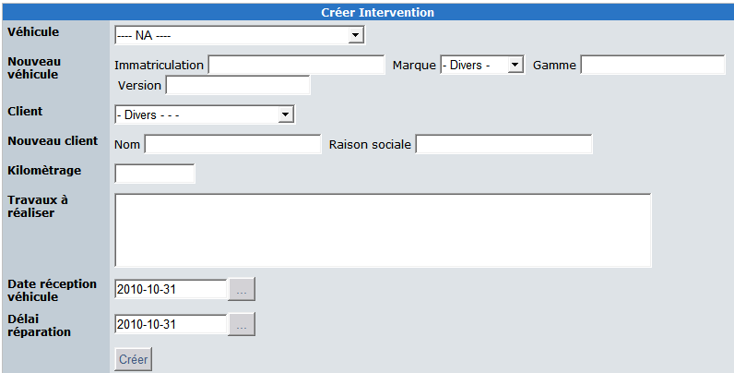

**Main data:**

The list of vehicles managed in the module is available in the first dropdown list.

You can of course add a new vehicle or a new customer directly in this form.

**Usefull data:**

Kilometers, repair task to do are required to create a new repair task.

The arrival date and the due date are used to sort emergency in the garage work.

Repair details are showing as follow in the user side:

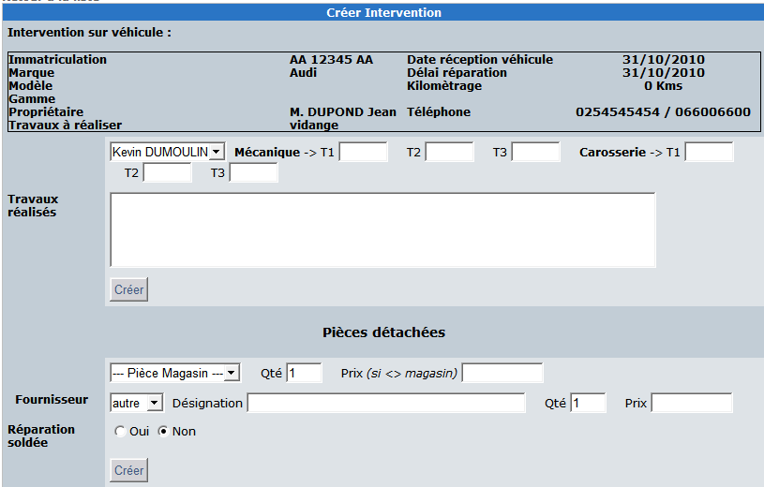

If at least one package is created by the admin a specific form is showed at the bottom of the screen: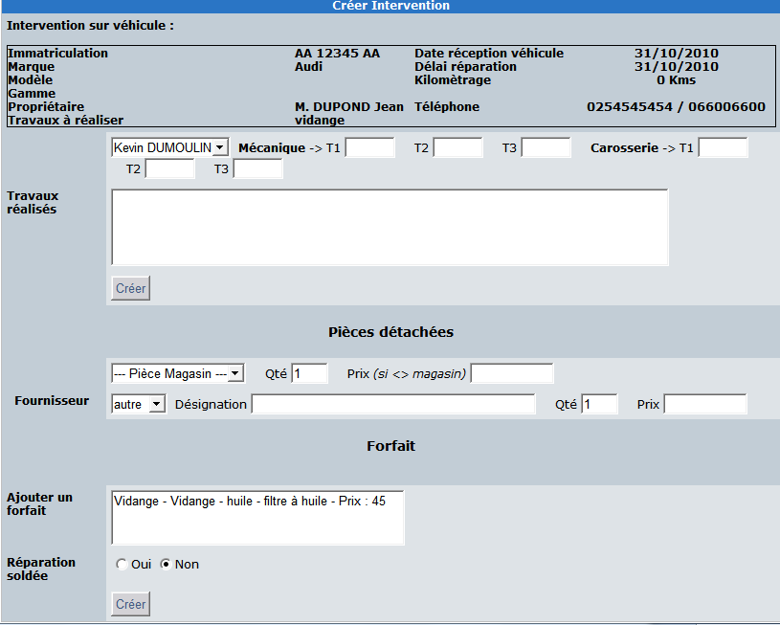

If an admin edit a repair task in the user side he can manage more data than a standard user.

He can add / delete some task :

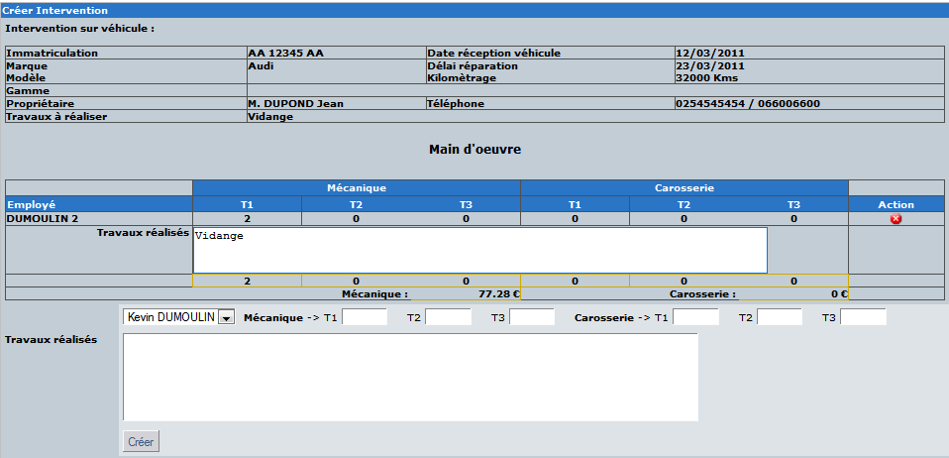

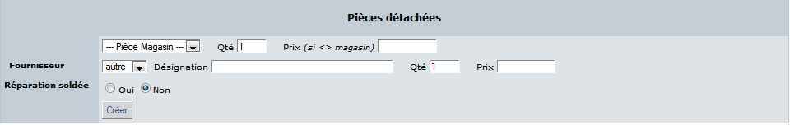

### Printing

The module can print quotation and invoices.

Some data as garage name can be managed in the preferences of the module.

**Quote**

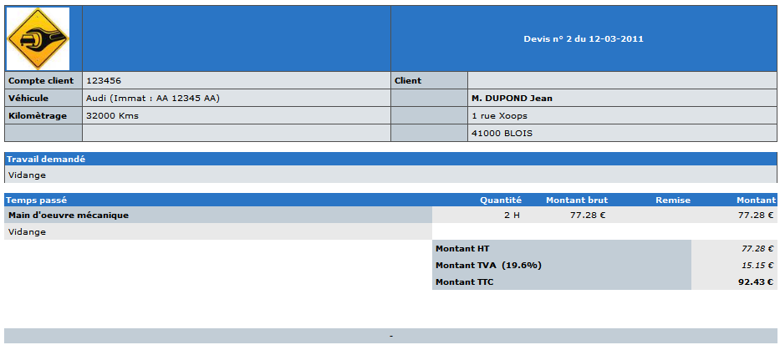

**Invoice**

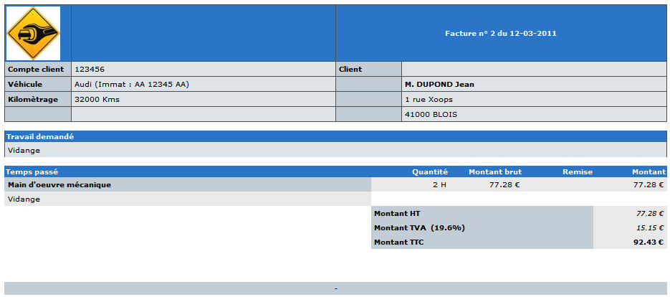

### Module preferences

You have many option to customize the module in the preferences.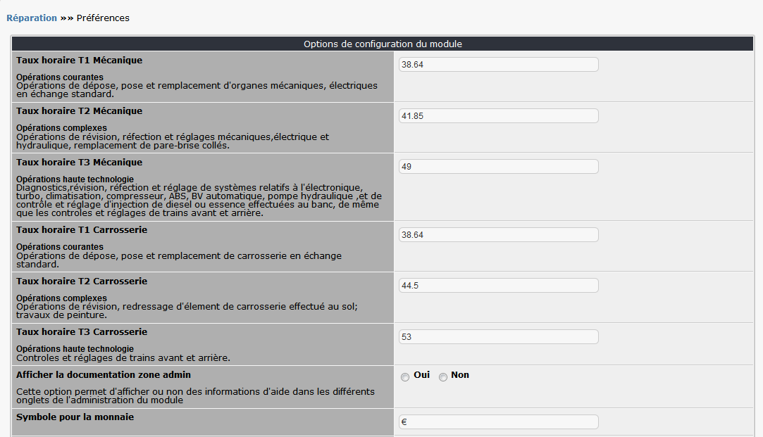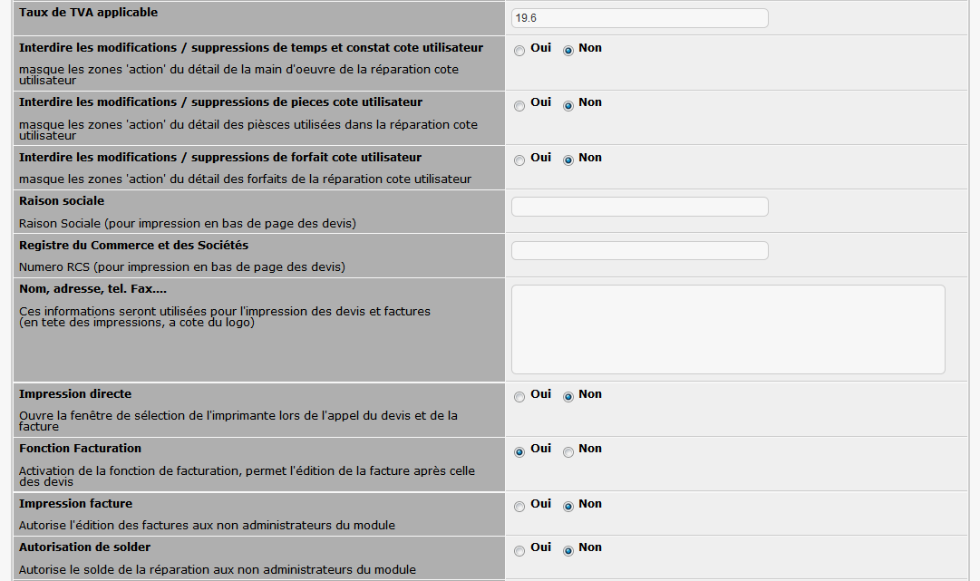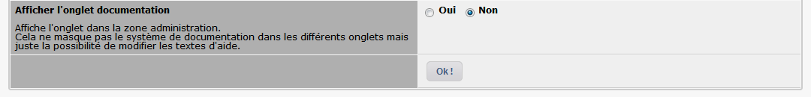

# User side

In the main menu you can choose repair task sorted by state.

3 states:

* **In progress**: the repair is created and not yet ended or not started. Of course it’s possible that you are just waiting the acceptation of the quote.
* **Ended**: the repair is terminated and the vehicle is given to the customer. The quote and the invoice have been printed.
* **Archived**: it’s necessary to store the history of the repair task so we keep the data in this area. I assume it’s a temporary solution and I’m working on this point for the next version of the module.

You can access to the repair in each state thru the main menu:

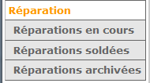

In the repair in progress it’s possible to create a new repair task, update a repair, print a quote or invoice.

If you have admin right you can access to the admin area with a clic on the key picture at the left top.

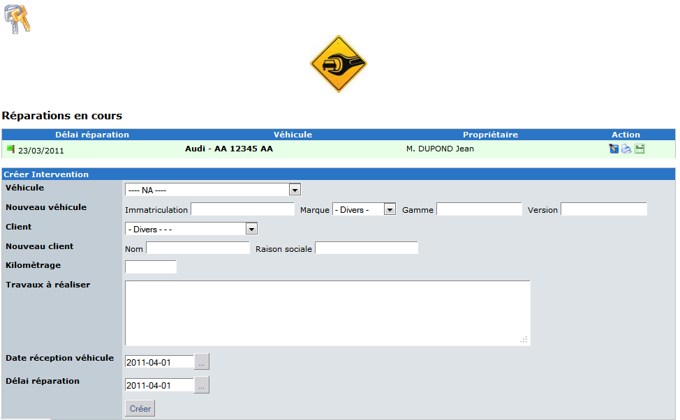

When all task are done for a repair you can « close » with the checkbox at the bottom of the modification form. (depending for the preferences. Always available for the admin and only for the user if allowed in the preferences module).

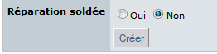

When the repair is closed you can archive it for keep it in history.

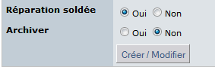

You can see repairs in each state area. A specific color prevent misunderstanding state.



Note: you always can print quote or invoice.



To improve the module, solve an issue, add a new feature or simply send me a comment, please send me an email at [masson.philippe@gmail.com](mailto:masson.philippe@gmail.com) or [philou@xoops.org](mailto:philou@xoops.org)